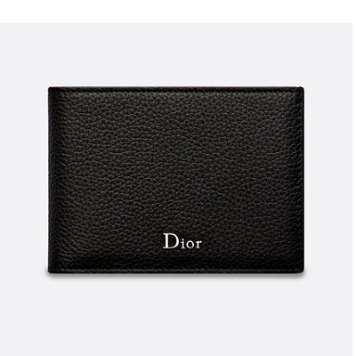

Black grained calfskin wallet

PRODUCT DETAILS

**Wallet**

**Black grained calfskin**

**Palladium-finish metallic "Dior" logo on the outside**

**Heat embossed "Dior" logo on the inside**

**8 card slots**

**2 compartments for banknotes and receipts**

**2 document compartments**

**1 zipped purse**

**11.5 x 8.5 C**